SIT305

Grading Criteria

Platform: [Unity]

Prefer: [on-campus]

By HONG LY (SID: 215350188)

My Email: hly@deakin.edu.au

# Marking Justification

|  |  |
| --- | --- |
| Critical Information Summary | |
| Student Name | HONG LY |
| SID | 215350188 |
| Mark Aimed For (%) | 95% |

### **Criteria: Code Commits [HD]**

☑ [Pass]

* At least 10 unique-day commits (per person).

☑ [Credit]

* At least 15 unique-day commits.

☑ [Distinction]

* At least 20 unique-day commits.

☑ [HD]

* At least 25 unique-day commits.

**Evidence:** I have commit and push source codes more than 25 unique-day. Below is the link to the changelog file.

<https://github.com/lyhd/Dragon-World/blob/master/changelog.txt>

### **Criteria: Weekly Progress (Changelog) [D]**

☑ [Pass]

* Changelog updated at least once a week (per person).

☑ [Credit]

* Changelog lists all new major features added per day-of-work, and a list of “Still working on” for current features in progress.

**Evidence:**

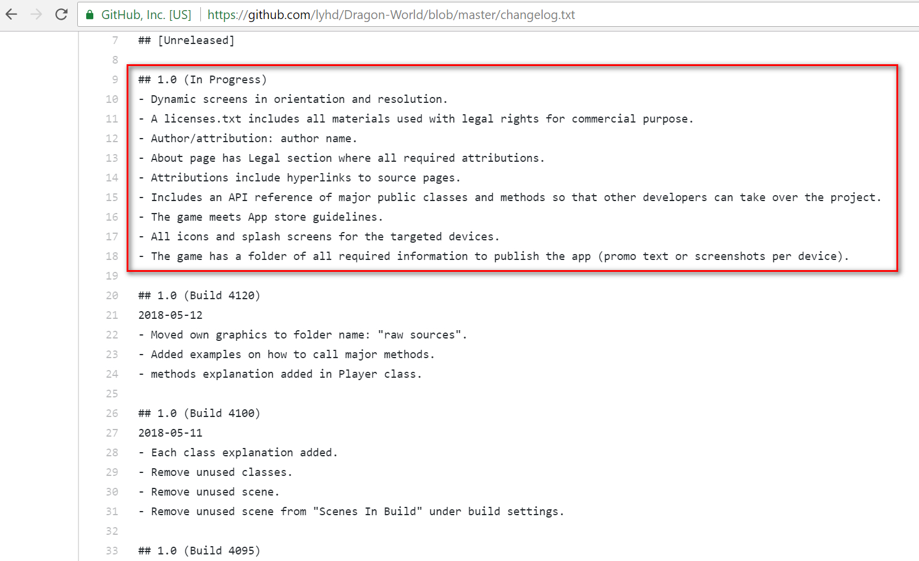

☑ [Distinction]

* Included at the end of each work day, a summary of how I am progressing related to the milestones.

**Evidence:**

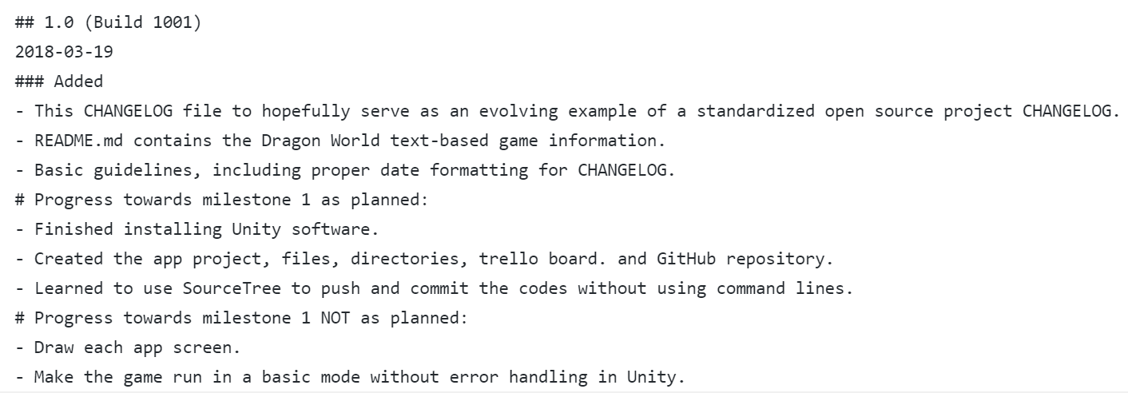

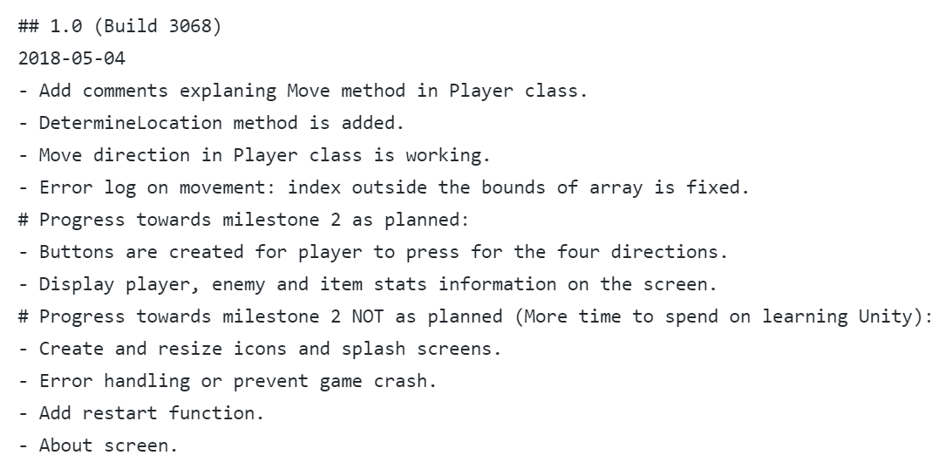

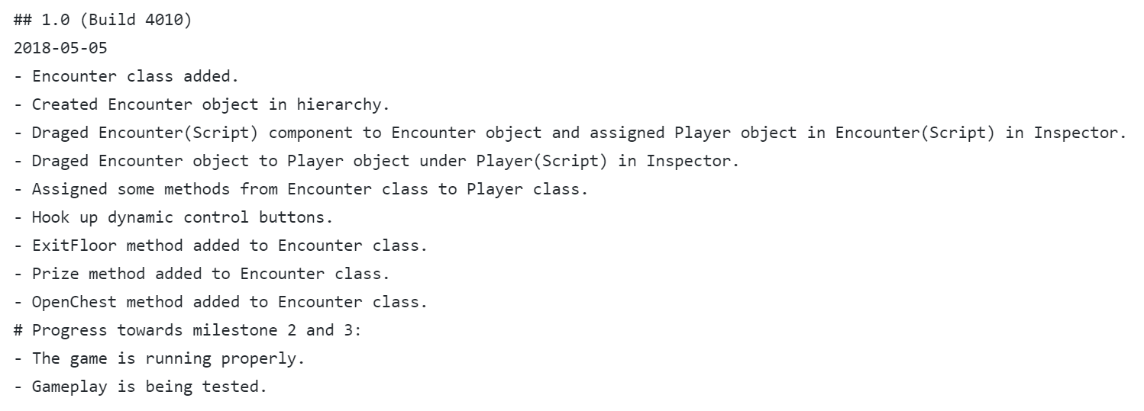

### **Criteria: Code Quality [D]**

☑ [Pass]

* Indentation is perfect. Every class, and each major method/function has a brief comment.

**Evidence:**

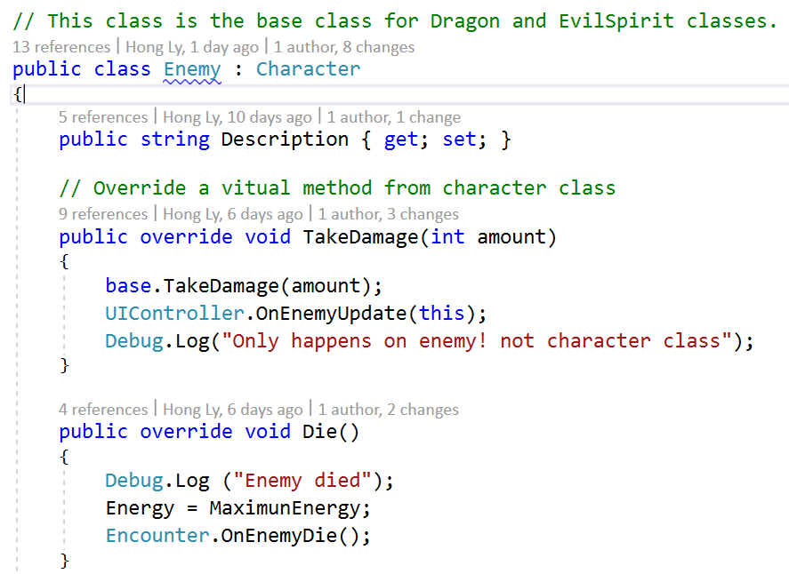

☑ [Credit]

* Every class, and each major method/function has an explanation comment, as well as method/function signature explanation.

**Evidence:**

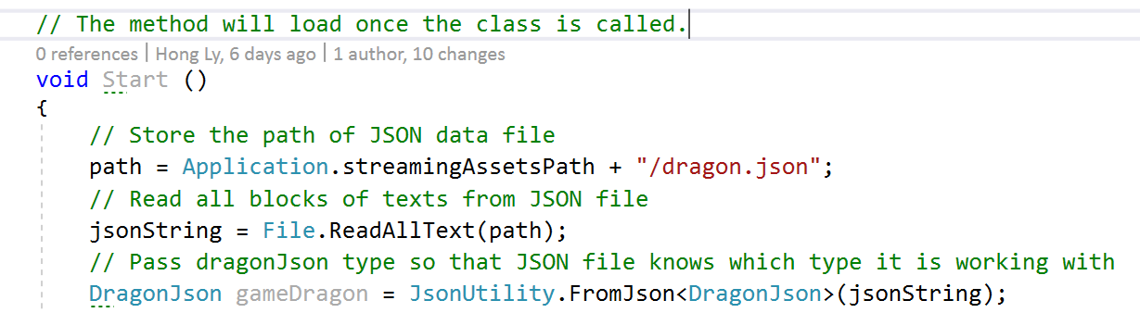

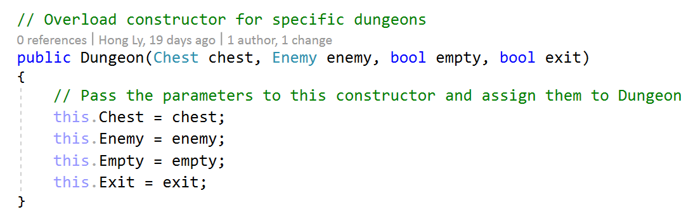

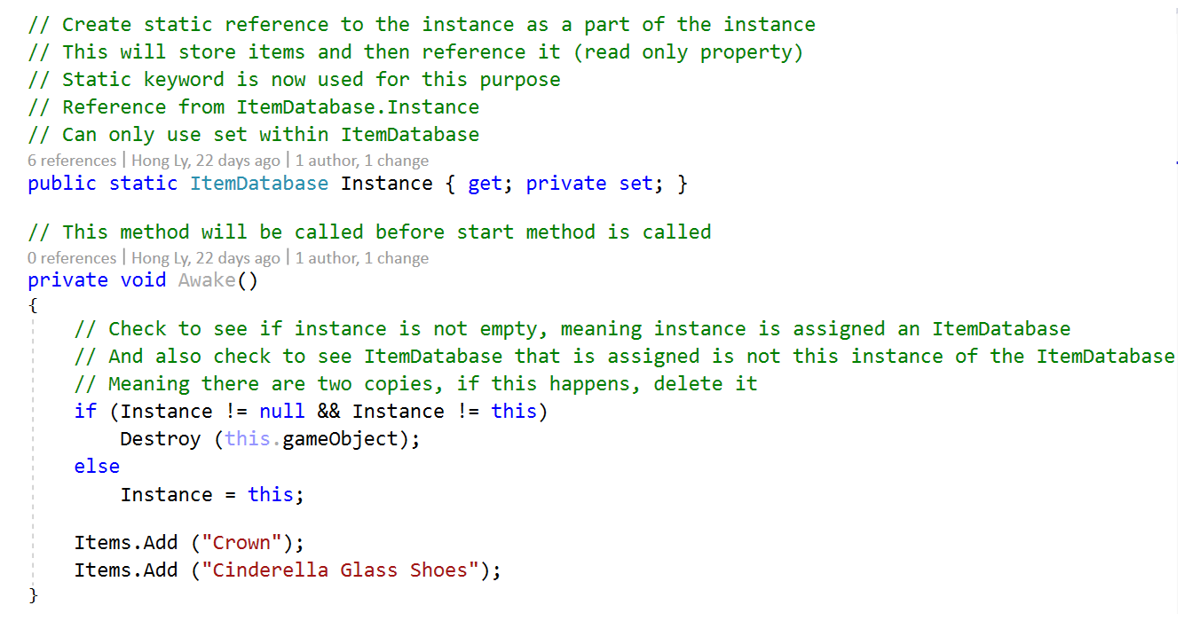

☑ [Distinction]

* Each major method has several examples of how to call it (parameters).
* Snippet examples of returned data for each method.

**Evidence:**

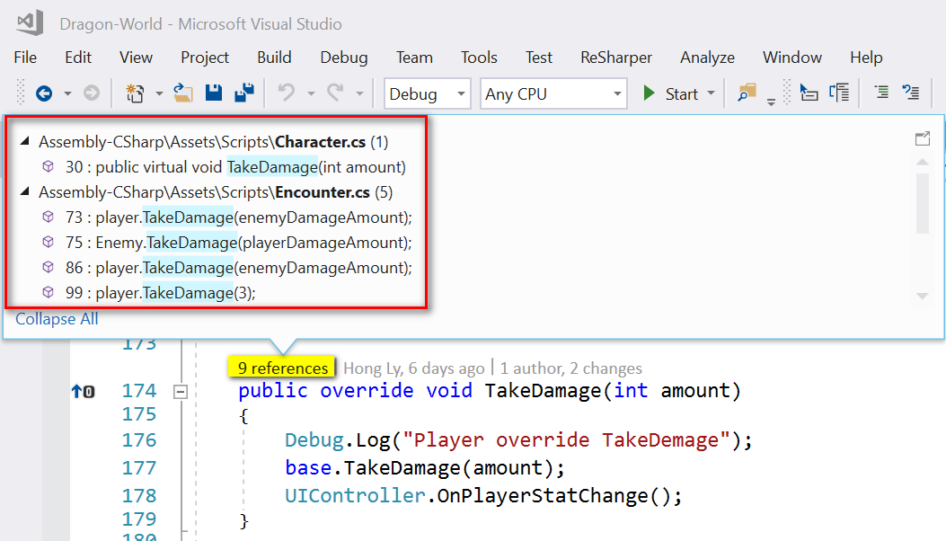

*TakeDamage method has been used 9 times as seen.*

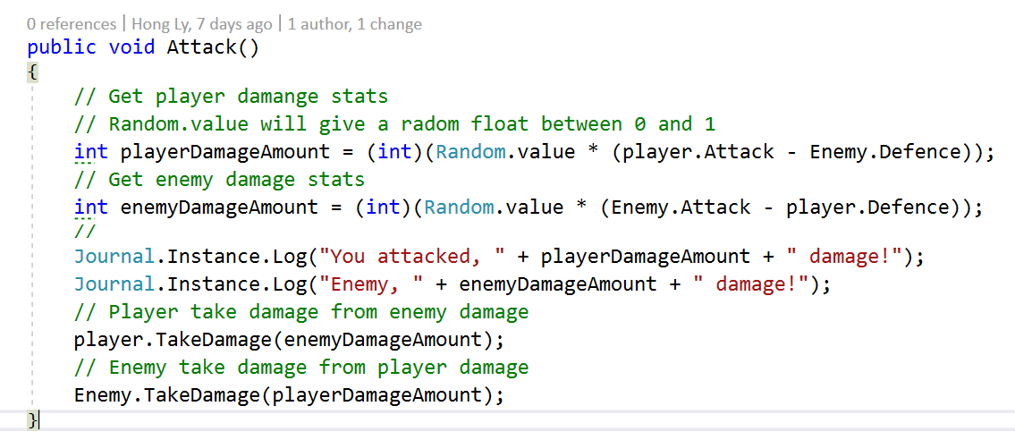

*TakeDamage method is used with different returned data.*

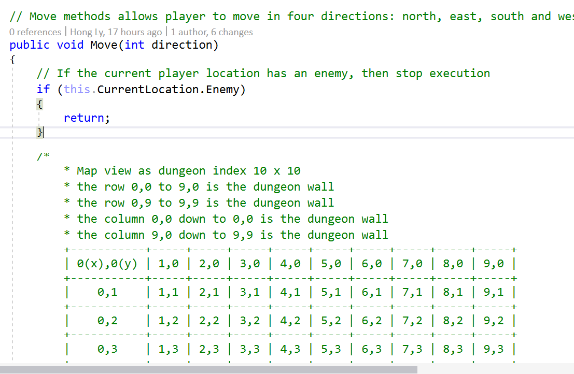

*Move method is used through Unity Inspector.*

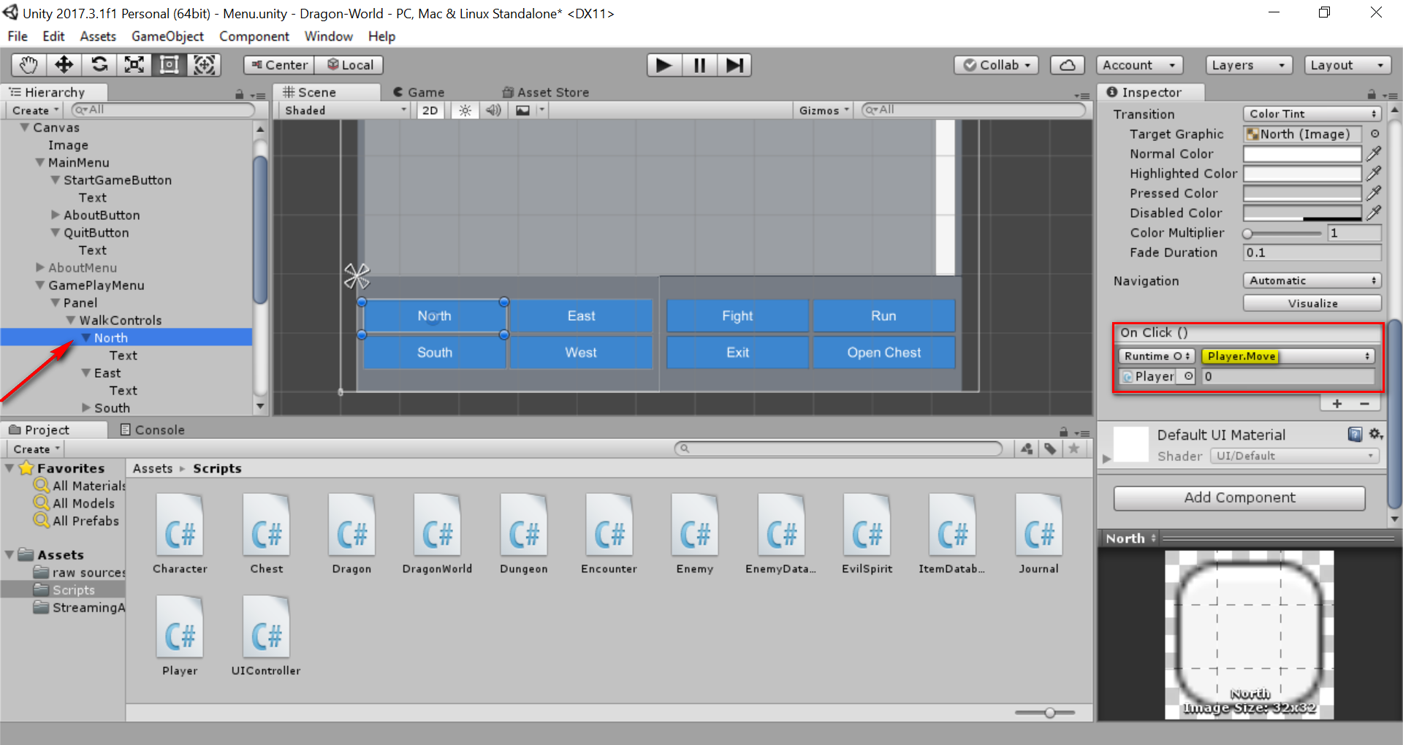

*Move method is used and assigned to walk controls with On Click event*

### **Criteria: Legal [D]**

[Pass]

* Have a licenses.txt file, and all materials that are used have legal rights to use for commercial use.

[Credit]

* Have a Legal section / About page with Legal section, where all attributions that are made are legally required to.

[Distinction]

* Item name: image, sound, method or class.
* License type: (Public Domain / CC-BY / CC0 / GPL / MIT / Apache / BSD).
* Author/attribution: author name.
* Attributions include hyperlinks to source pages.

### **Criteria: Playability [HD]**

[Pass]

* Your game is engaging to play for at least 30 minutes.

[Credit]

* Your game is engaging to play for at least 2 hours.

[Distinction]

* Your game is engaging to play for at least 5 hours.

[High Distinction]

* Your game is engaging to play for at least 10 hours.

### **Criteria: Data Handling [HD]**

[Pass]

* You load all your game data through local text files.

[Credit]

* You also have all app constants in local text files.

[Distinction]

* Load and save user settings to an external file or DB.

[High Distinction]

* Load and save user state from/to external file or DB.
* Easy to create, edit and update.

### **Criteria: Layout [D]**

[Pass]

* Your app works in portrait phone mode.

[Credit]

* Your app works in both portrait phone, tablet portrait, and tablet landscape mode.

[Distinction]

* Dynamically adjusts in real-time in orientation and resolution.

### **Criteria: Bugs [D]**

[Pass]

* Code gracefully handles all bugs, and restarts or resumes as appropriate.

[Credit]

* code also keeps all data safe and saved, as well as captures and details and reports bugs to the end user at a high level.

[Distinction]

* Your code also keeps a log page, that the end user can access, listing all bugs captured.

### **Criteria: Readme.md [HD]**

☑ [Pass]

* Includes your name, app title, app platform, link to GitHub, and an overview of your app.

**Evidence:**

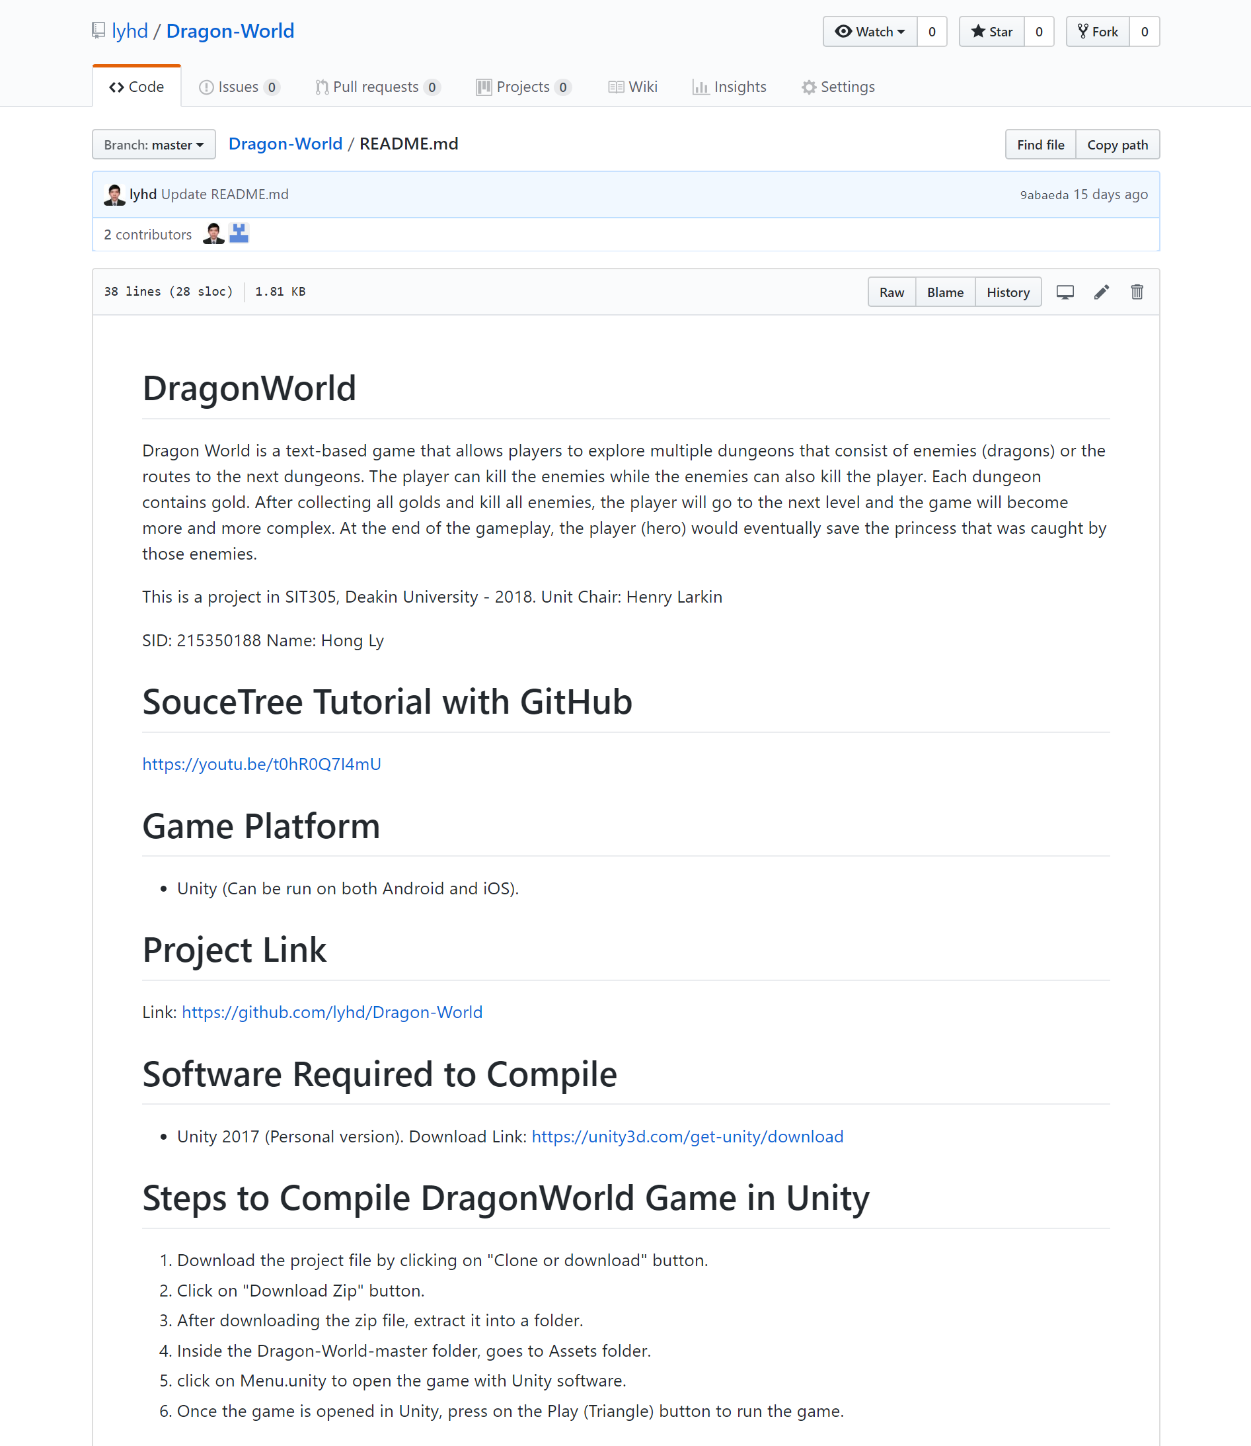

☑ [Credit]

* Includes an explanation of major features.

**Evidence:**

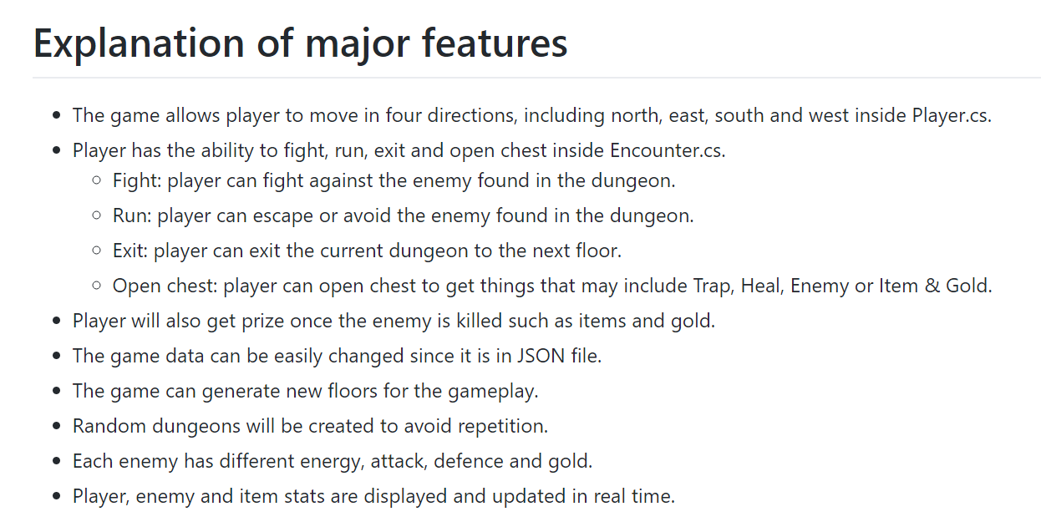

☑ [High Distinction]

* Includes an API reference of major public classes and methods so that other developers can take over the project.

**Evidence:**

### 

Link: <https://github.com/lyhd/Dragon-World/blob/master/README.md>

### **Criteria: Publishing [HD]**

[Pass]

* Your app meets all App Store Guidelines.

[Credit]

* All icons and splash screens for the targeted devices.

[Distinction]

* The game has a folder of all required information to publish the app (promo text or screenshots per device).

[High Distinction]

* The game is published.

### **Criteria: Demonstration Video [D]**

[Pass]

* Demonstrate all main features of the app that you wish to be graded for.

[Credit]

* Video and audio are clear and easy to understand.

[Distinction]

* Your video has a professional feel to it, to the level similar to company YouTube videos.

* Note: There is no HD rubric for Weekly Progress, Code Quality, Legal, Layout, Bugs, and Demonstration Video.